AI Social Support Application Workflow Automation – Architectural Assessment and Service Analysis
1. System Overview
The AI Social Support Application Platform automates eligibility decisions for government social-support programs. It achieves this by orchestrating a modular microservice ecosystem that ingests, extracts, validates, and scores applicant data using AI and ML components. The system provides transparent, explainable decisioning augmented by interactive LLM-based dialogue.
The platform embodies a hybrid architecture combining symbolic (rule-based) and statistical (ML/LLM-based) reasoning under strict data governance. The overall goal is to automate up to 99% of eligibility decisions within minutes.

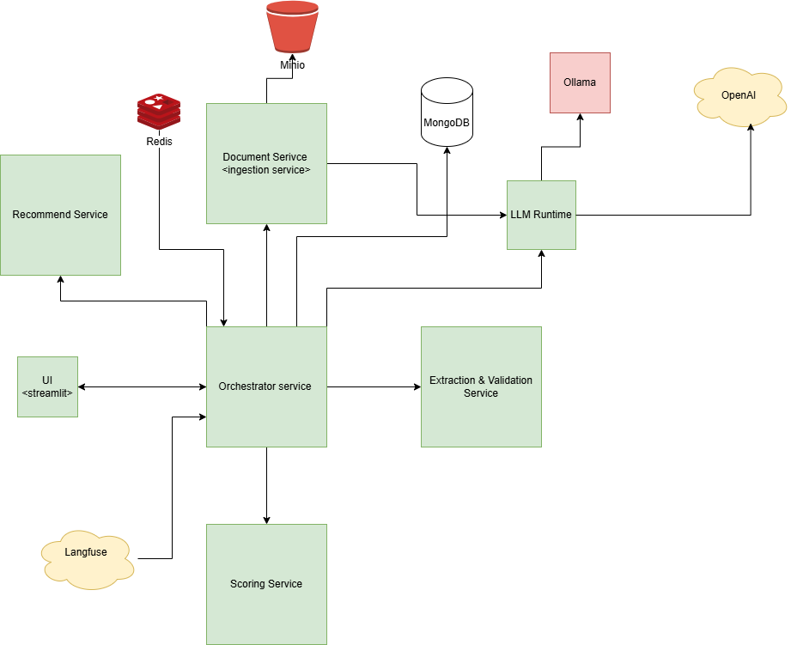
2. High-Level Architecture
Core Services:
- Documents Service – Handles ingestion, storage (MinIO), and OCR/text parsing.
- Extract & Validate Service – Performs domain-specific data extraction (EID, bank, assets, credit, resume) and rule-based validation.
- Score Service (ML Eligibility) – Converts normalized facts into structured features, applies trained ML models, and provides probability + SHAP explainability.
- Orchestrator Service – Coordinates multi-agent decision flow using ReAct/Reflexion reasoning via CrewAI and local LLM runtime.
- LLM Runtime – A gRPC gateway around Ollama/OpenAI-compatible models for local language generation.
- Recommend Service – Generates employment/training recommendations from applicant resumes using skill-based taxonomies and optional LLM polishing.
- Streamlit UI – A wizard-style front-end that enables caseworkers to upload, review, and chat interactively with the AI pipeline.
Shared Packages:
- Schemas – Pydantic models for all data contracts.
- LLM Protos – gRPC stubs for the LLM Runtime.
Supporting Systems:
- MinIO – Object store for raw documents.
- MongoDB – Application and extraction record database.
- Redis – In-memory store for chat sessions and clarifications.
- Langfuse – Observability for LLM traces and latency tracking.

3. Service-by-Service Deep Assessment
3.1 Extract & Validate Service
Purpose:
Transforms raw uploaded documents into structured factual representations and performs policy/rule-based validation.
Key Components:
- Extract Router: Calls dedicated parsers for EID, bank statements, assets/liabilities, credit reports, and resumes.
- Validate Router: Executes deterministic validation (income mismatch, EID expiry, IBAN format, name/address/DOB consistency).
- LLM RPC Client: Connects to LLM Runtime via gRPC for resume parsing.
- MinIO Client: Fetches raw document files securely.
AI & Reasoning:
- Extraction Phase: Combines rule-based parsing with LLM JSON extraction for unstructured text (resumes).
- Validation Phase: Implements domain heuristics plus symbolic policy rules, forming a Reflexion-like reasoning loop—the LLM and validation agent collaborate to self-correct and flag ambiguities.
Why This Design:
- Ensures interpretability and determinism in policy checks.
- Enables LLM-assisted adaptability for semi-structured documents (e.g., resumes, employment letters).
- Scales horizontally and isolates domain logic per document type.

3.2 Score Service (ML Eligibility Scoring)
Purpose:
Provides a probabilistic eligibility decision with explainability for each applicant.
Key Components:
- Feature Builder (features.py): Converts normalized application data into deterministic numeric feature vectors.
- Model Trainer (train.py): Trains and calibrates Logistic Regression or Gradient Boosting classifiers.
- Threshold Selector (thresholds.py): Derives decision boundaries based on target precision and recall.
- Explainer (explain.py): Uses SHAP values for per-feature contribution analysis.
Algorithmic Justification:
- Logistic Regression was chosen for its transparency and interpretability — ideal for government decision audits.
- CalibratedClassifierCV provides probabilistic calibration via Platt scaling.
- SHAP Explainability ensures human-readable transparency of model reasoning, crucial for Responsible AI compliance.
- Thresholding supports a 3-tier policy outcome:
  - APPROVE (high confidence)
  - REVIEW (borderline)
  - SOFT_DECLINE (low confidence)
Strengths:
- Modular feature schema promotes versioned, explainable models.
- Compatible with tabular or mixed-mode ML pipelines.
- Easily extensible for fairness monitoring (e.g., bias detection on gender/nationality).

3.3 Orchestrator Service
Purpose:
Acts as the central intelligence coordinating all agents (Extraction, Validation, Reconciliation, Decision).
Architecture:
- Built on CrewAI with local LLM reasoning adapter.
- Implements ReAct + Reflexion frameworks:
  - ReAct (Reason + Act) enables step-wise reasoning with tool calls.
  - Reflexion allows the agent to critique and revise prior outputs.
- Each agent represents a specific workflow domain:
  - Extraction Agent – Ensures factual consistency of document parsing.
  - Validation Agent – Applies policy logic and calls rule validators.
  - Reconciliation Agent – Aligns inconsistent values across sources; may trigger clarification via chat.
  - Decision Agent – Synthesizes ML score + validation findings into final outcome.
Explainable Decision Pipeline:
- Extract → Validate → Reconcile → Decide
- Each agent communicates via CrewAI, invoking microservice APIs through dedicated tools.
- Redis Chat Integration: Allows clarification questions to be surfaced to users directly from the pipeline.
Why This Design:
- Decouples cognitive reasoning into specialized sub-agents, improving traceability.
- Supports human-in-the-loop review through chat clarifications.
- Implements transparent auditability, showing every intermediate step in decision logic.

3.4 LLM Runtime Service
Purpose:
Provides a provider-agnostic local interface for text generation, enabling privacy-preserving inference.
Design:
- gRPC-based LlmRuntime service exposing Generate, GenerateStream, and Health endpoints.
- Adheres to protobuf contracts shared via llm_protos.
- Supports local Ollama models or remote OpenAI-compatible endpoints.
Why gRPC:
- Low-latency, binary transport suitable for multi-service AI orchestration.
- Ensures consistent message schema and backward compatibility.
Benefit:
- Enables unified LLM access across extraction, recommendation, and orchestration agents.
- Ensures on-premise operation for data sovereignty compliance.

3.5 Recommend Service
Purpose:
Provides employment role matching and skill gap analysis based on resume facts and skill taxonomies.
AI Components:
- Rules Engine (rules.py) – Deterministic skill overlap scoring.
- Taxonomy Loader (taxonomy.py) – Imports JSON-based role definitions with core/nice-to-have skills and training programs.
- Recommender (recommender.py) – Generates ranked role suggestions and training recommendations.
Reasoning Logic:
- Symbolic similarity (skill overlap) rather than black-box neural matching for interpretability.
- LLM client (optional): Refines text explanations via local LLM polishing.
Strengths:
- Explainable output (“matched 8/10 core skills”).
- Extensible for career development modules.
- Supports integration into post-eligibility enablement programs.

4. AI Reasoning Frameworks
The system applies agentic orchestration combining:
- ReAct Framework: Interleaving reasoning steps with tool usage for transparency.
- Reflexion Framework: Agents iteratively refine outputs based on prior reasoning feedback.
- PaS (Plan-and-Solve): Implemented implicitly in run_multi_agent_pipeline, where sequential agent results feed subsequent reasoning stages.
This combination ensures self-corrective, interpretable decision flows suitable for regulated environments.

5. Toolchain Justification
Layer | Technology | Justification
API & Routing | FastAPI | Async, type-safe, easy auto-doc generation
Model Training | scikit-learn | Robust tabular ML, explainable, regulatory safe
Feature Processing | pandas, numpy, pydantic | Deterministic data pipeline
Explainability | SHAP | Transparent feature-level attribution
Reasoning | CrewAI + Local LLM Adapter | Structured multi-agent orchestration
Data Storage | MongoDB / MinIO / Redis | Polyglot persistence per use-case
Deployment | Docker Compose | Modular, reproducible environments
Observability | Langfuse | LLM tracing and latency metrics

6. Scalability & Security
- Scalability: Stateless microservices, containerized, horizontally scalable under load.
- Security: Local LLM ensures data privacy and compliance with national data-residency mandates.
- Maintainability: Shared schema packages avoid API drift; each service independently versioned.
- Performance: gRPC + Redis caching reduce latency in multi-agent chat loops.

7. Future Enhancements
- Fairness Auditing: Integrate demographic bias checks in the scoring model.
- RAG-based Resume Analysis: Enhance skill extraction with domain embeddings.
- Knowledge Graph (Neo4j): For household-level dependency modeling.
- Streamlit Chat Analytics: Display agent reasoning chains and SHAP plots.
- Continuous Model Monitoring: Track ROC-AUC drift and re-train thresholds.

8. Conclusion
This architecture demonstrates a mature, explainable AI governance framework, blending structured ML, rule-based validation, and agentic reasoning with LLM-powered interactivity.
It achieves a balance between automation efficiency and human oversight, aligning with public-sector AI ethics and transparency mandates.

